M1 (Solution of linear systems)

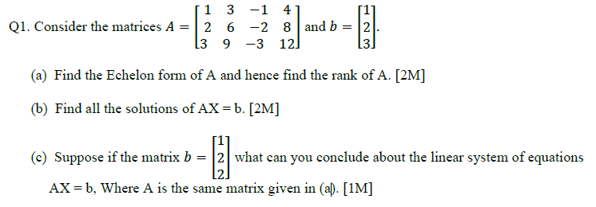

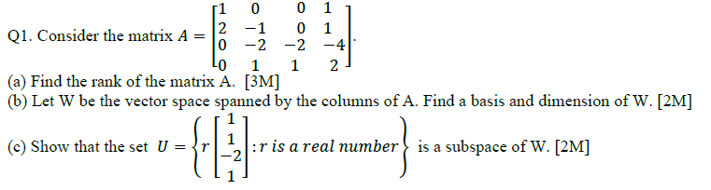

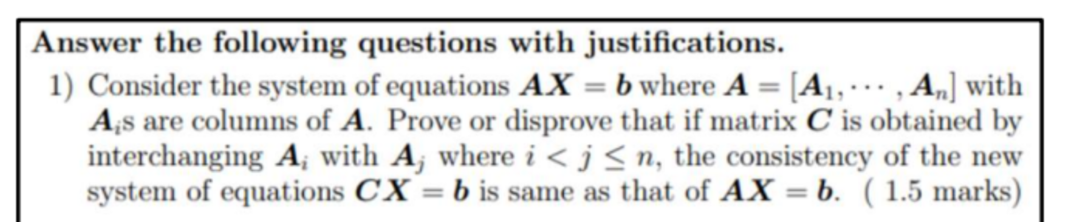

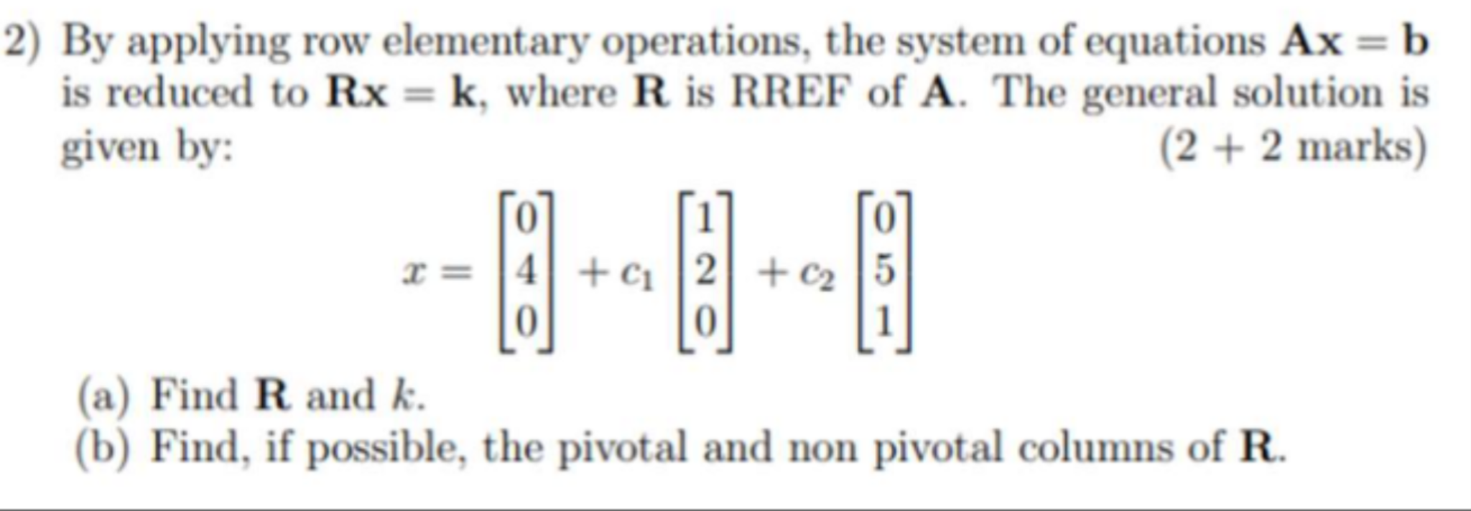

**2020 MidSem Regular**

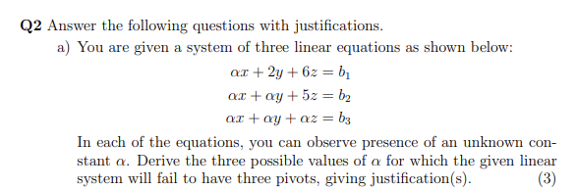

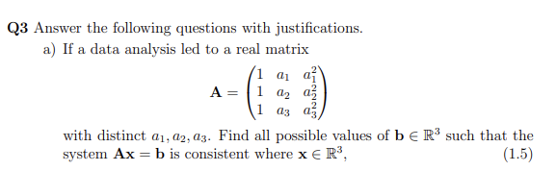

**2021 MidSem**

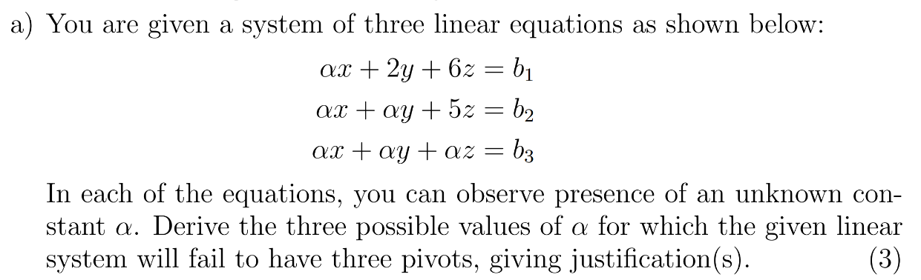

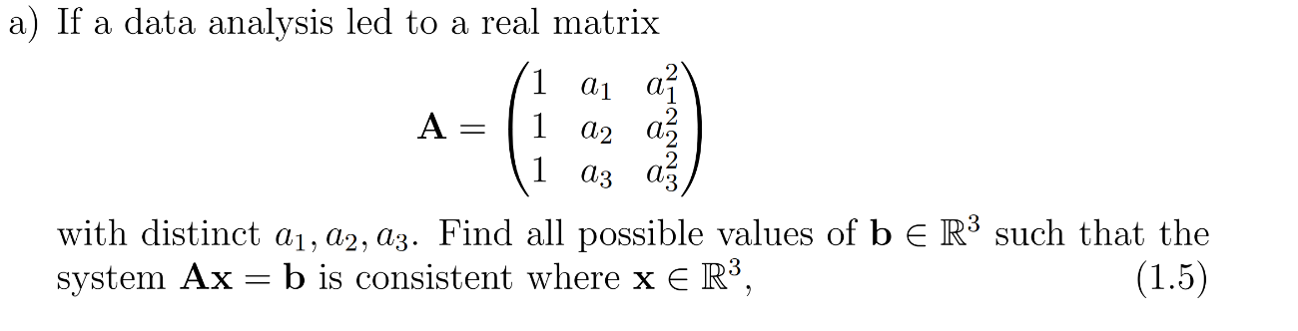

**2022 EndSem Makeup**

Q3 (1) ii

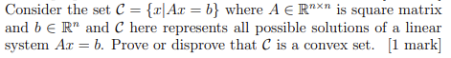

M2 — Vector Spaces

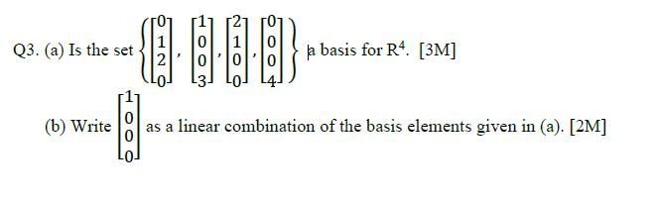

**2020 MidSem Regular**

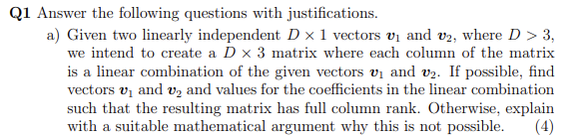

**Q3**

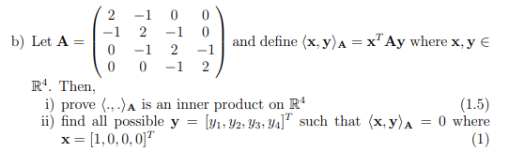

**2021 MidSem**

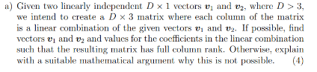

**2022 MidSem**

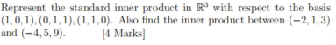

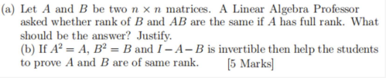

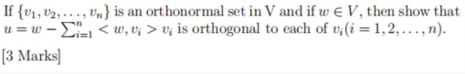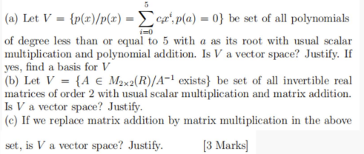

**2022 EndSem Regular**

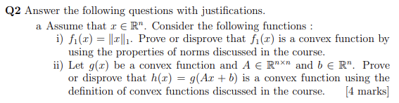

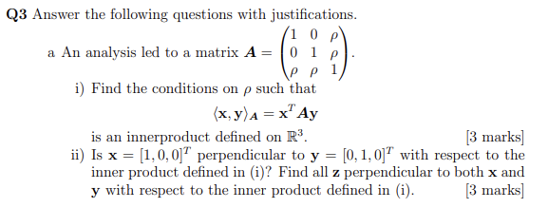

**2022 EndSem Makeup**

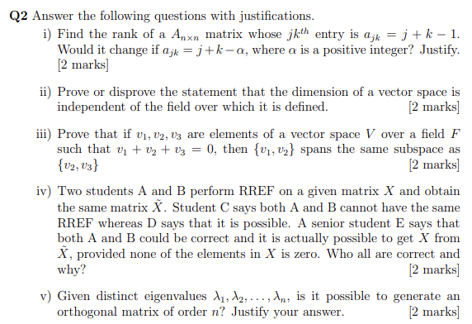

**Q4**

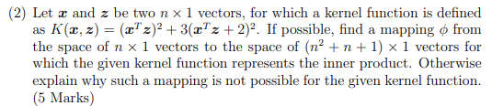

**2023 EndSem Makeup**

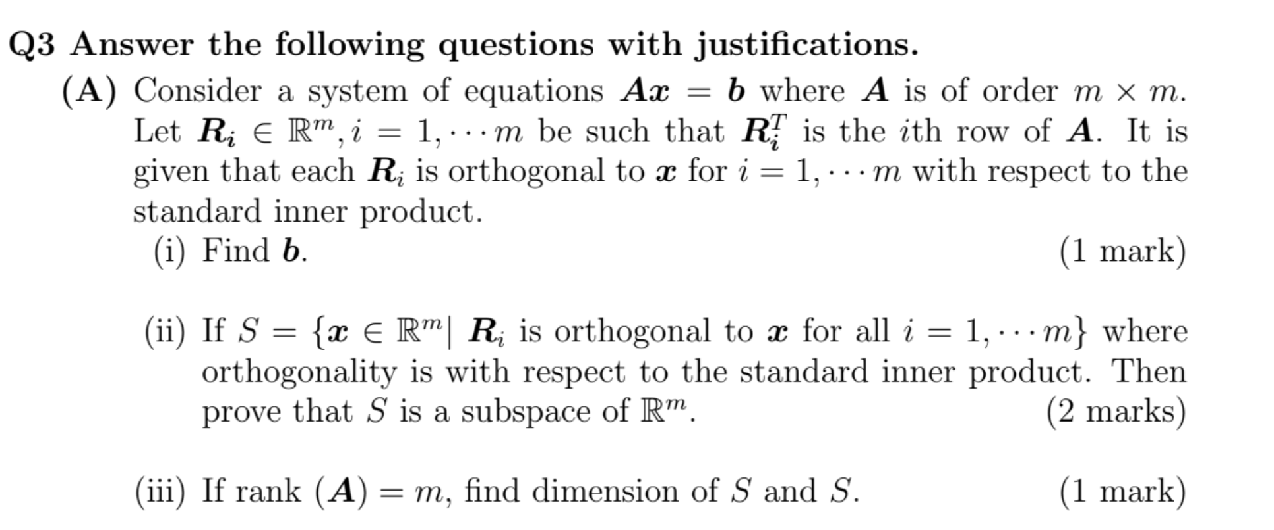

**2023 EndSem Regular**

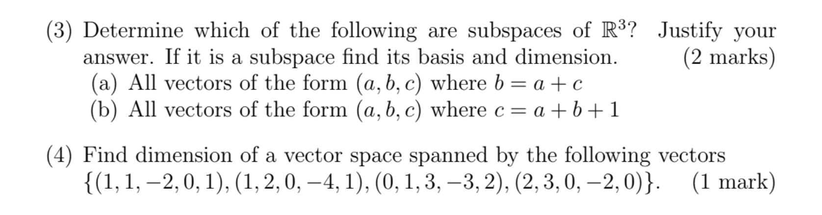

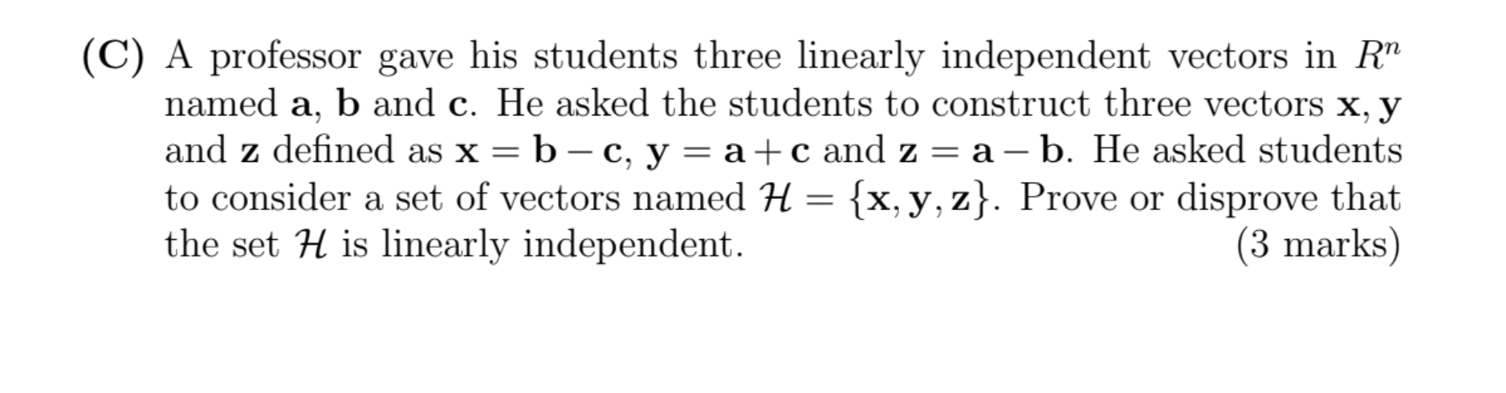

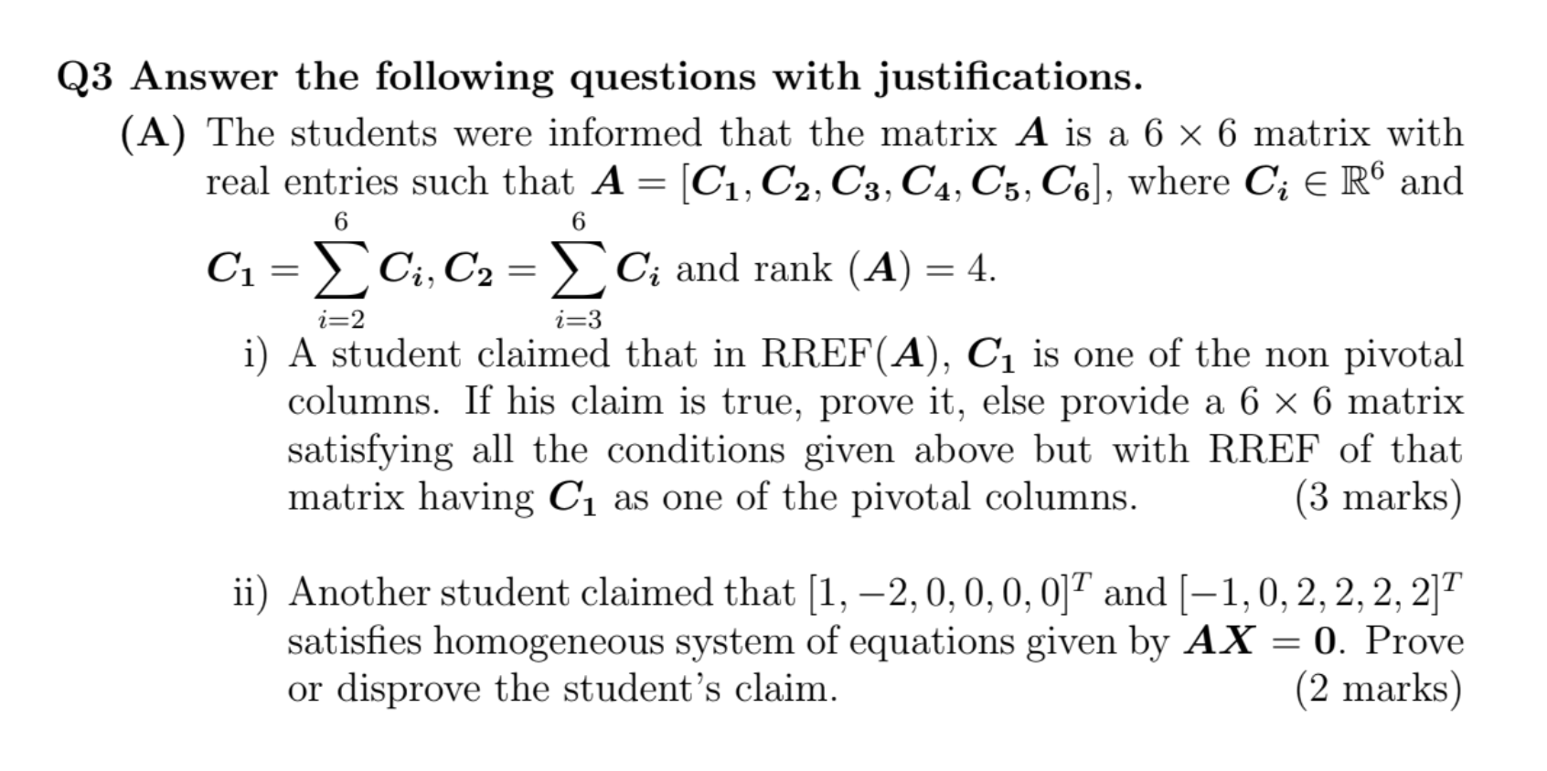

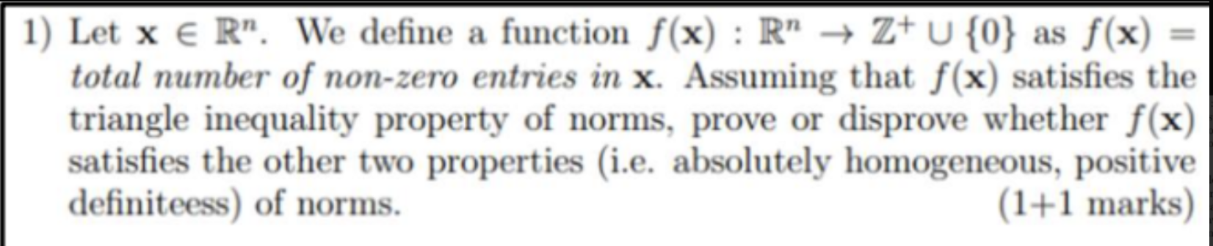

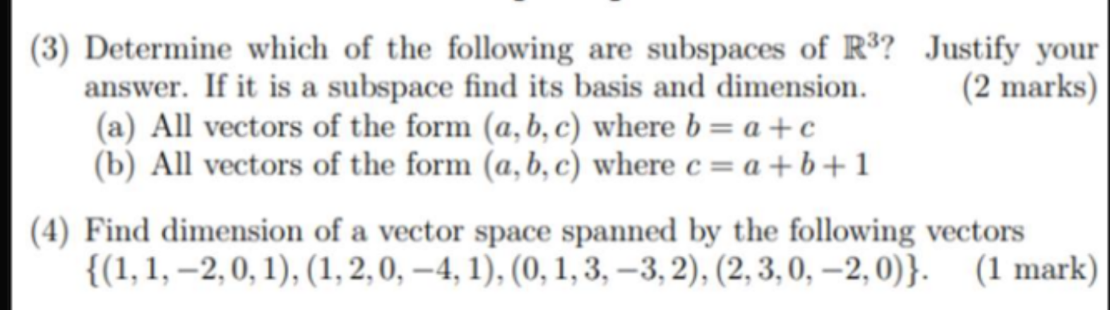

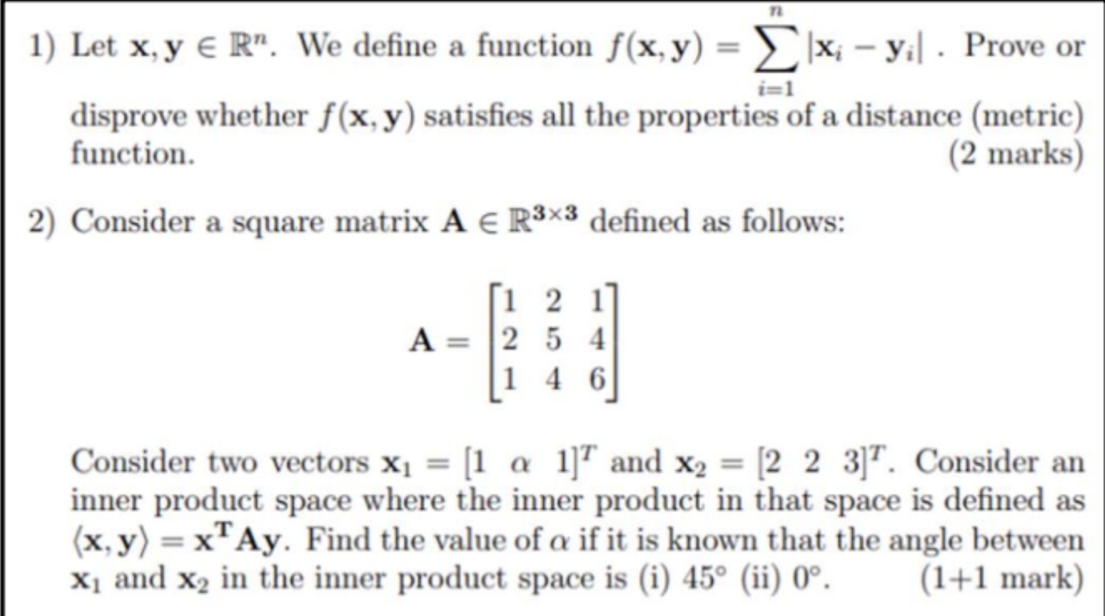

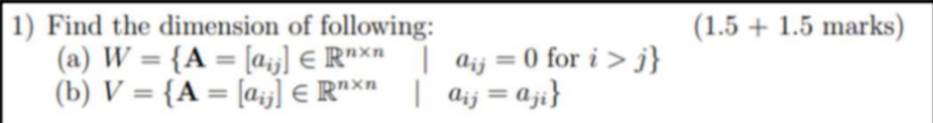

M3 — Matrix Decomposition

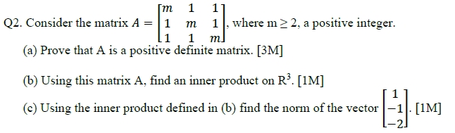

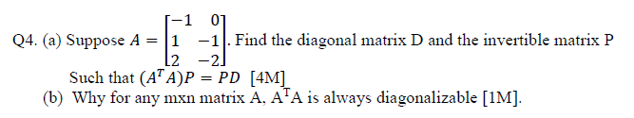

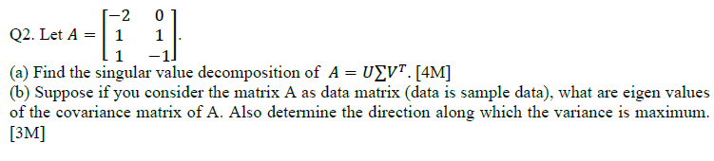

**2020 MidSem Regular**

**Q2**

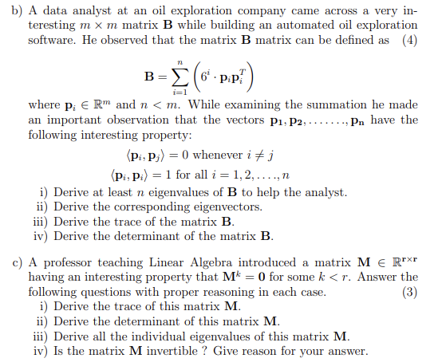

**2021 MidSem**

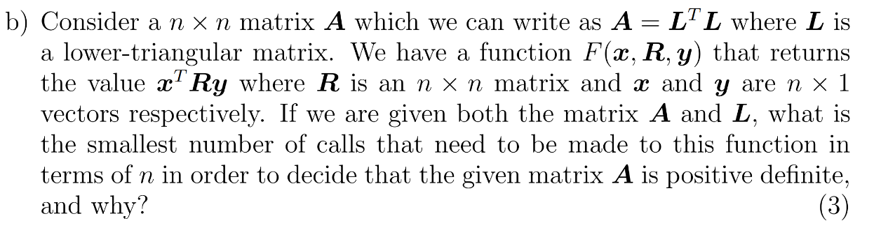

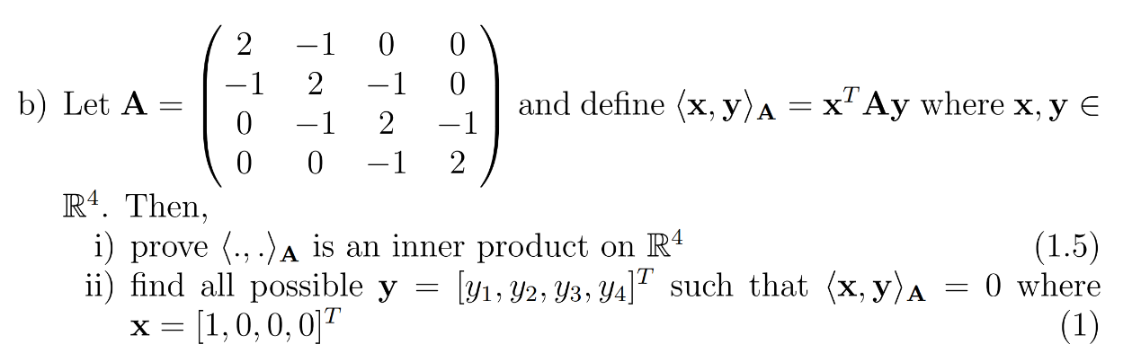

**2022 MidSem**

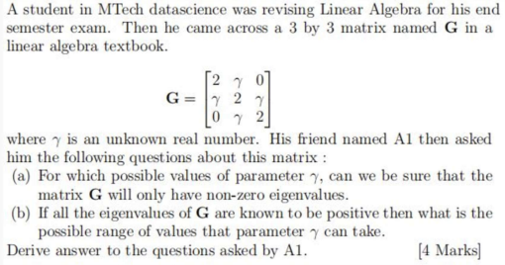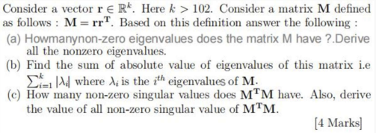

**2022 EndSem Regular**

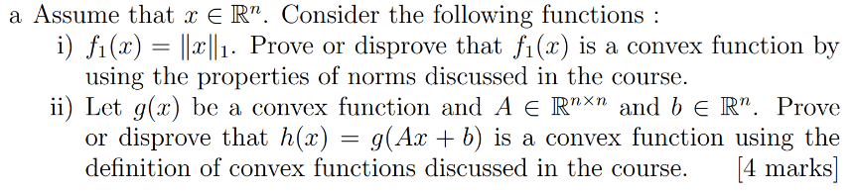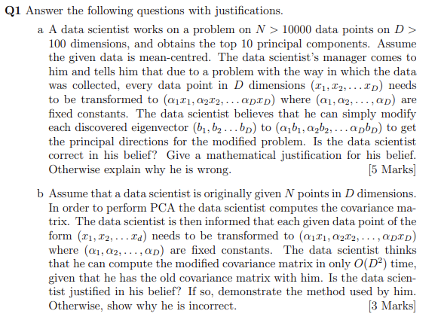

**Q2**

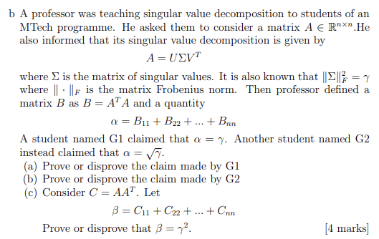

**Q3**

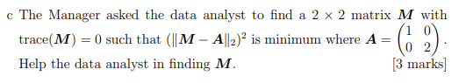

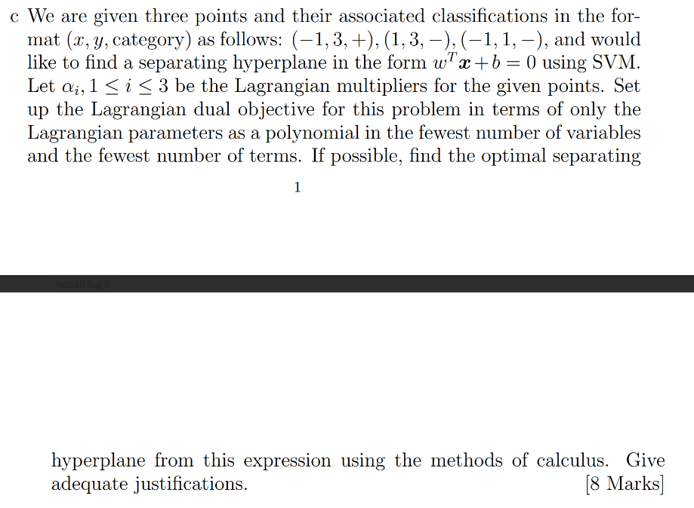

**2022 EndSem Makeup**

**Q1**

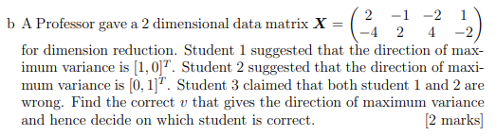

**Q3**

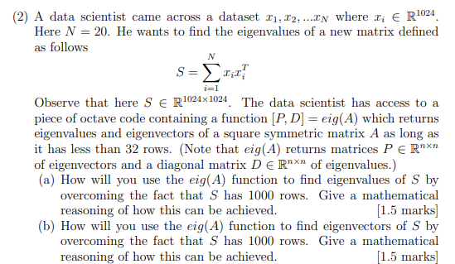

**2023 EndSem Makeup**

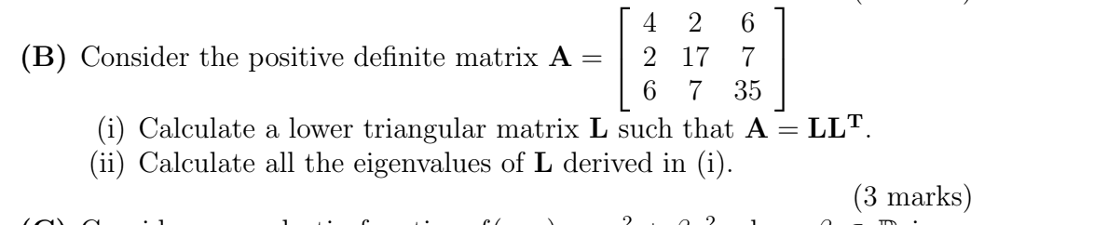

**2023 EndSem Regular**

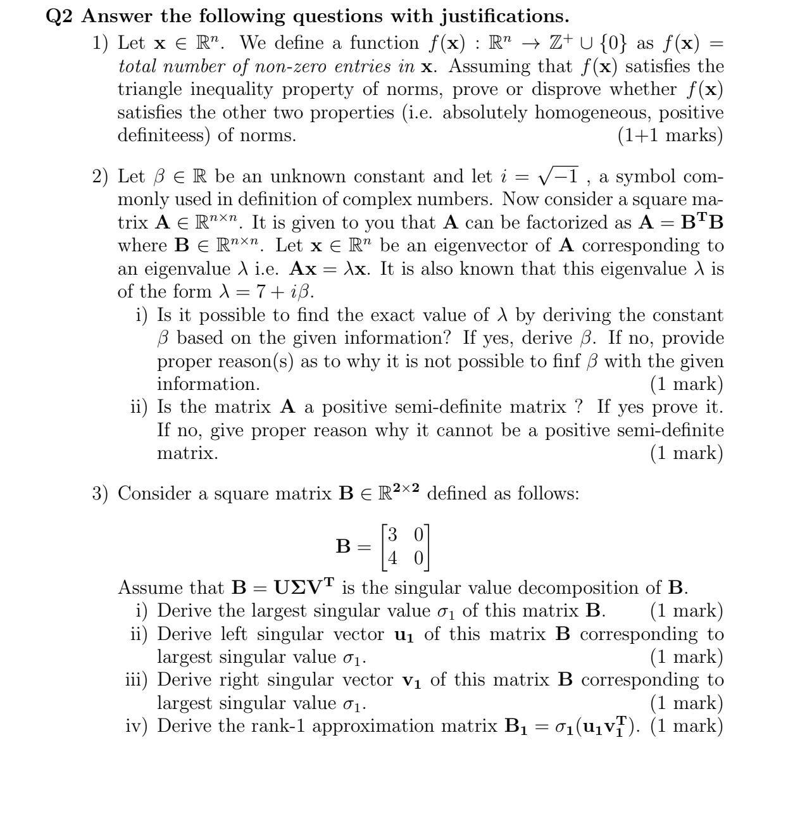

**2023 EndSem Regular**

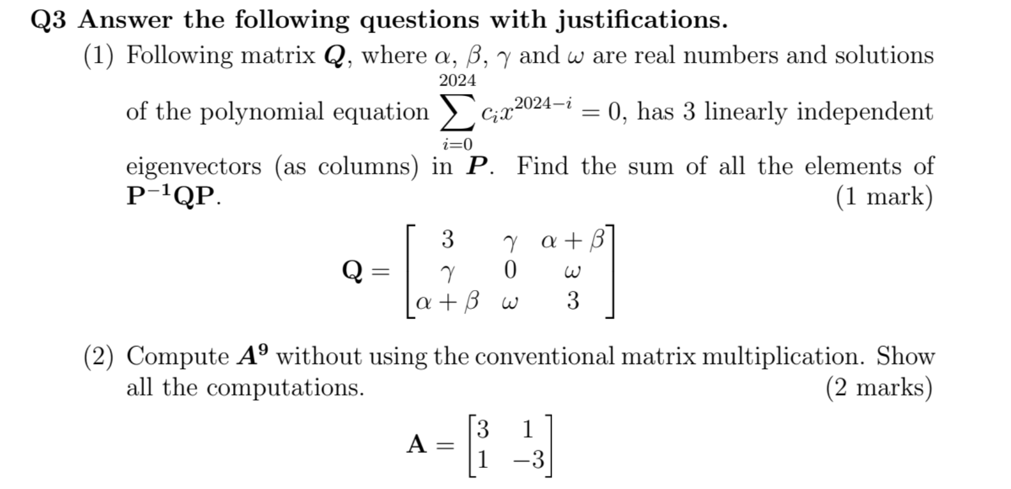

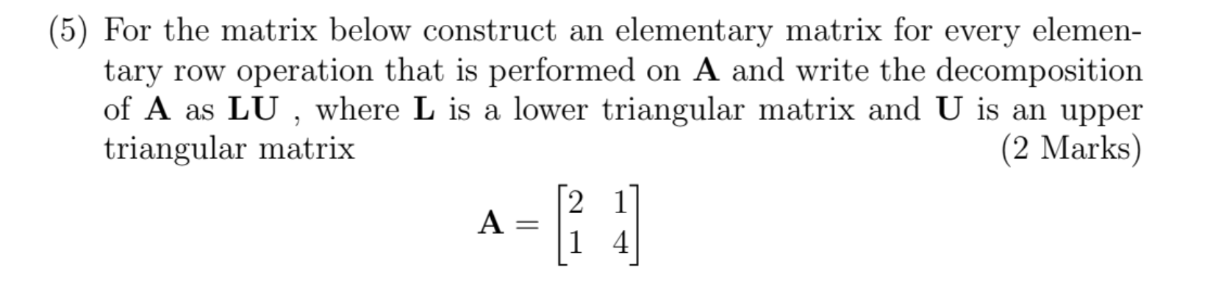

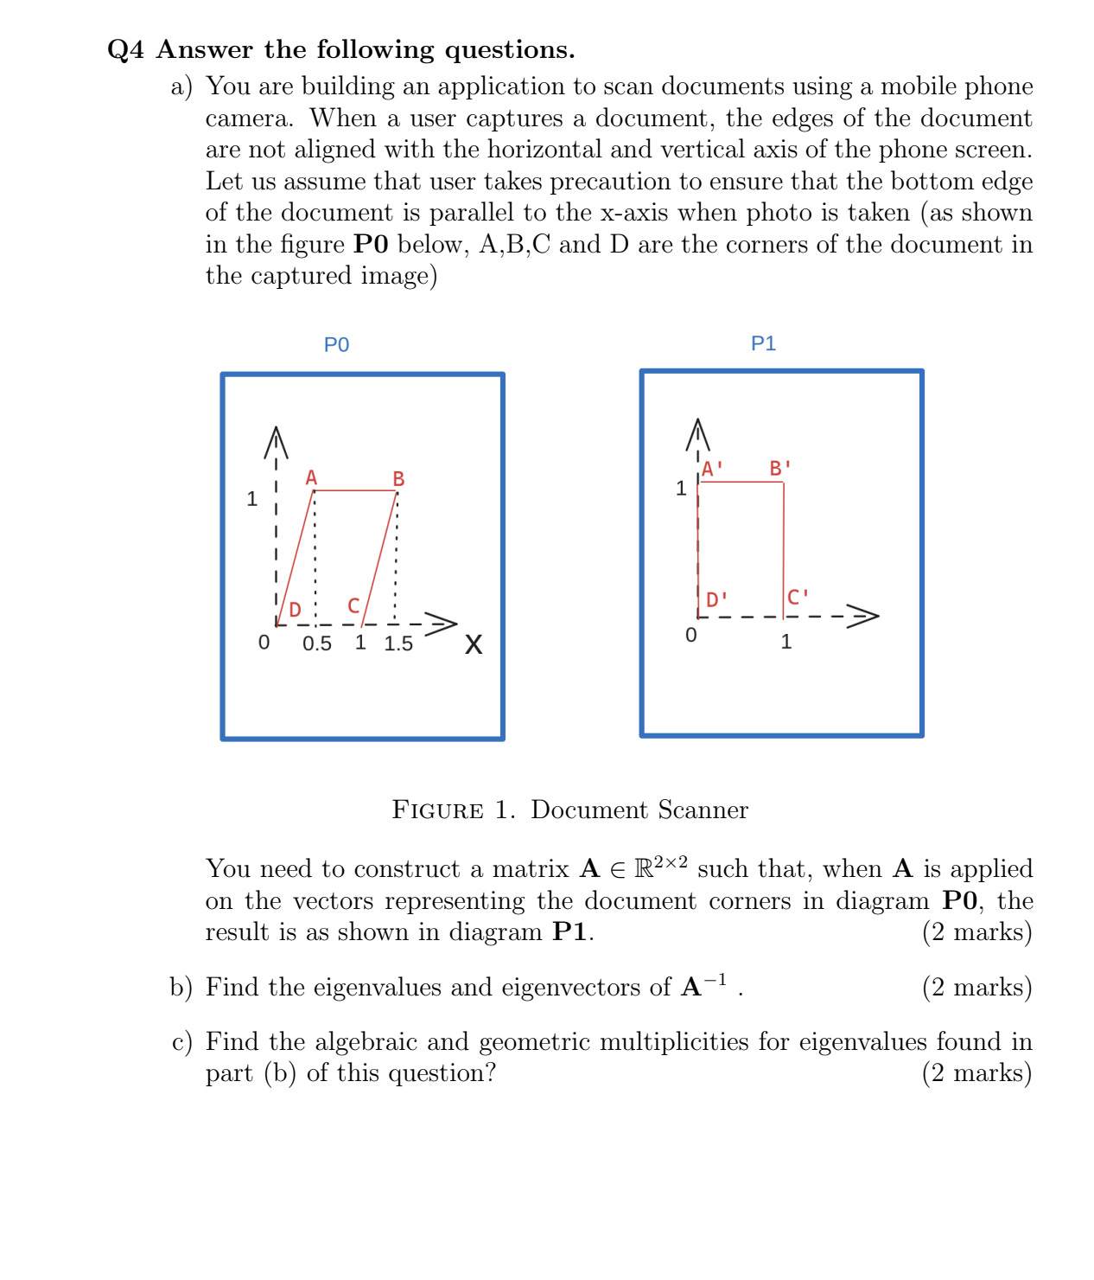

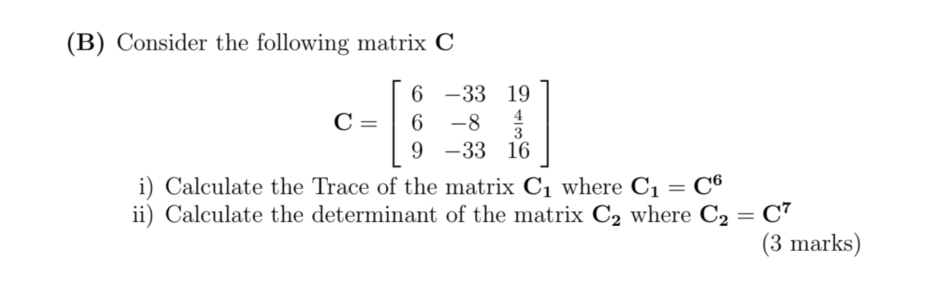

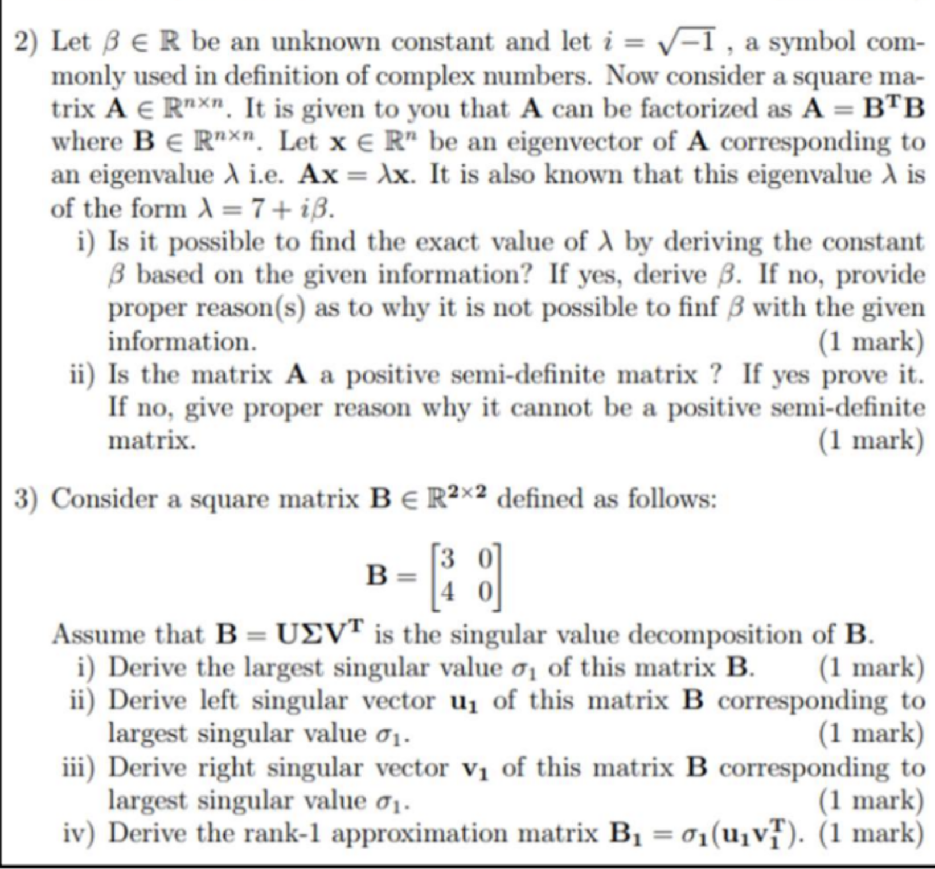

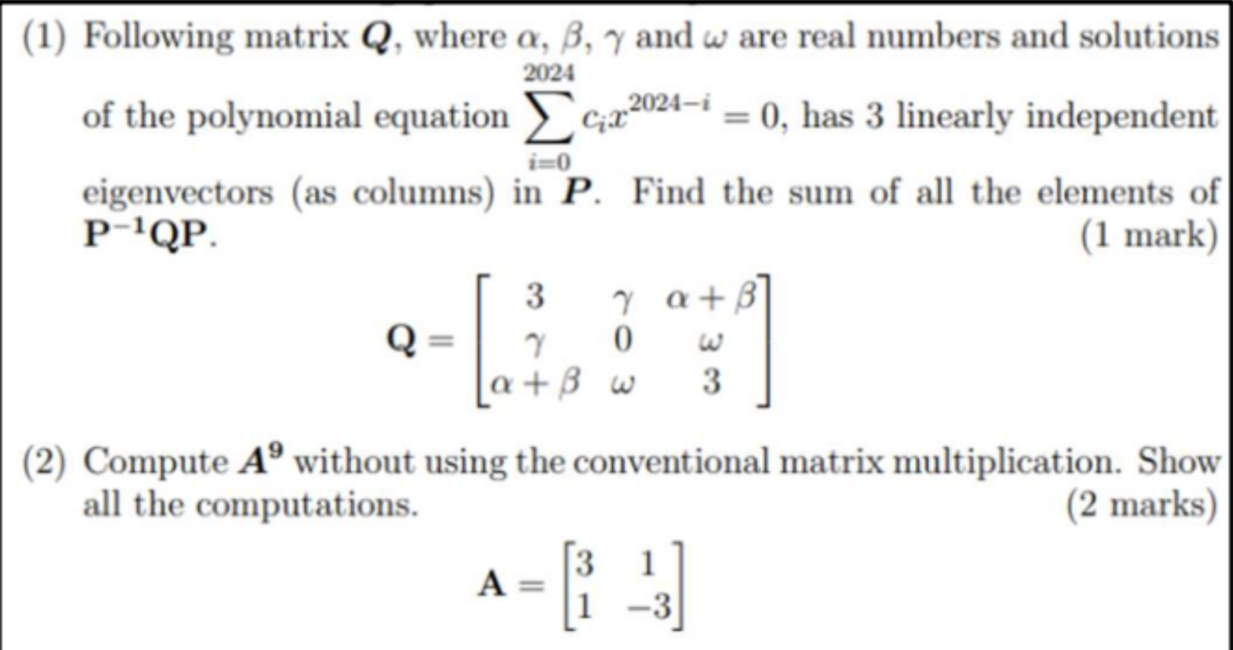

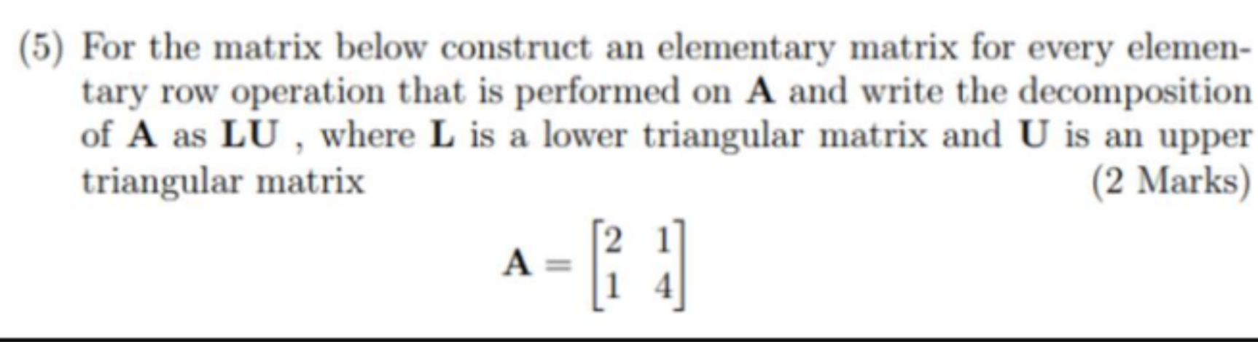

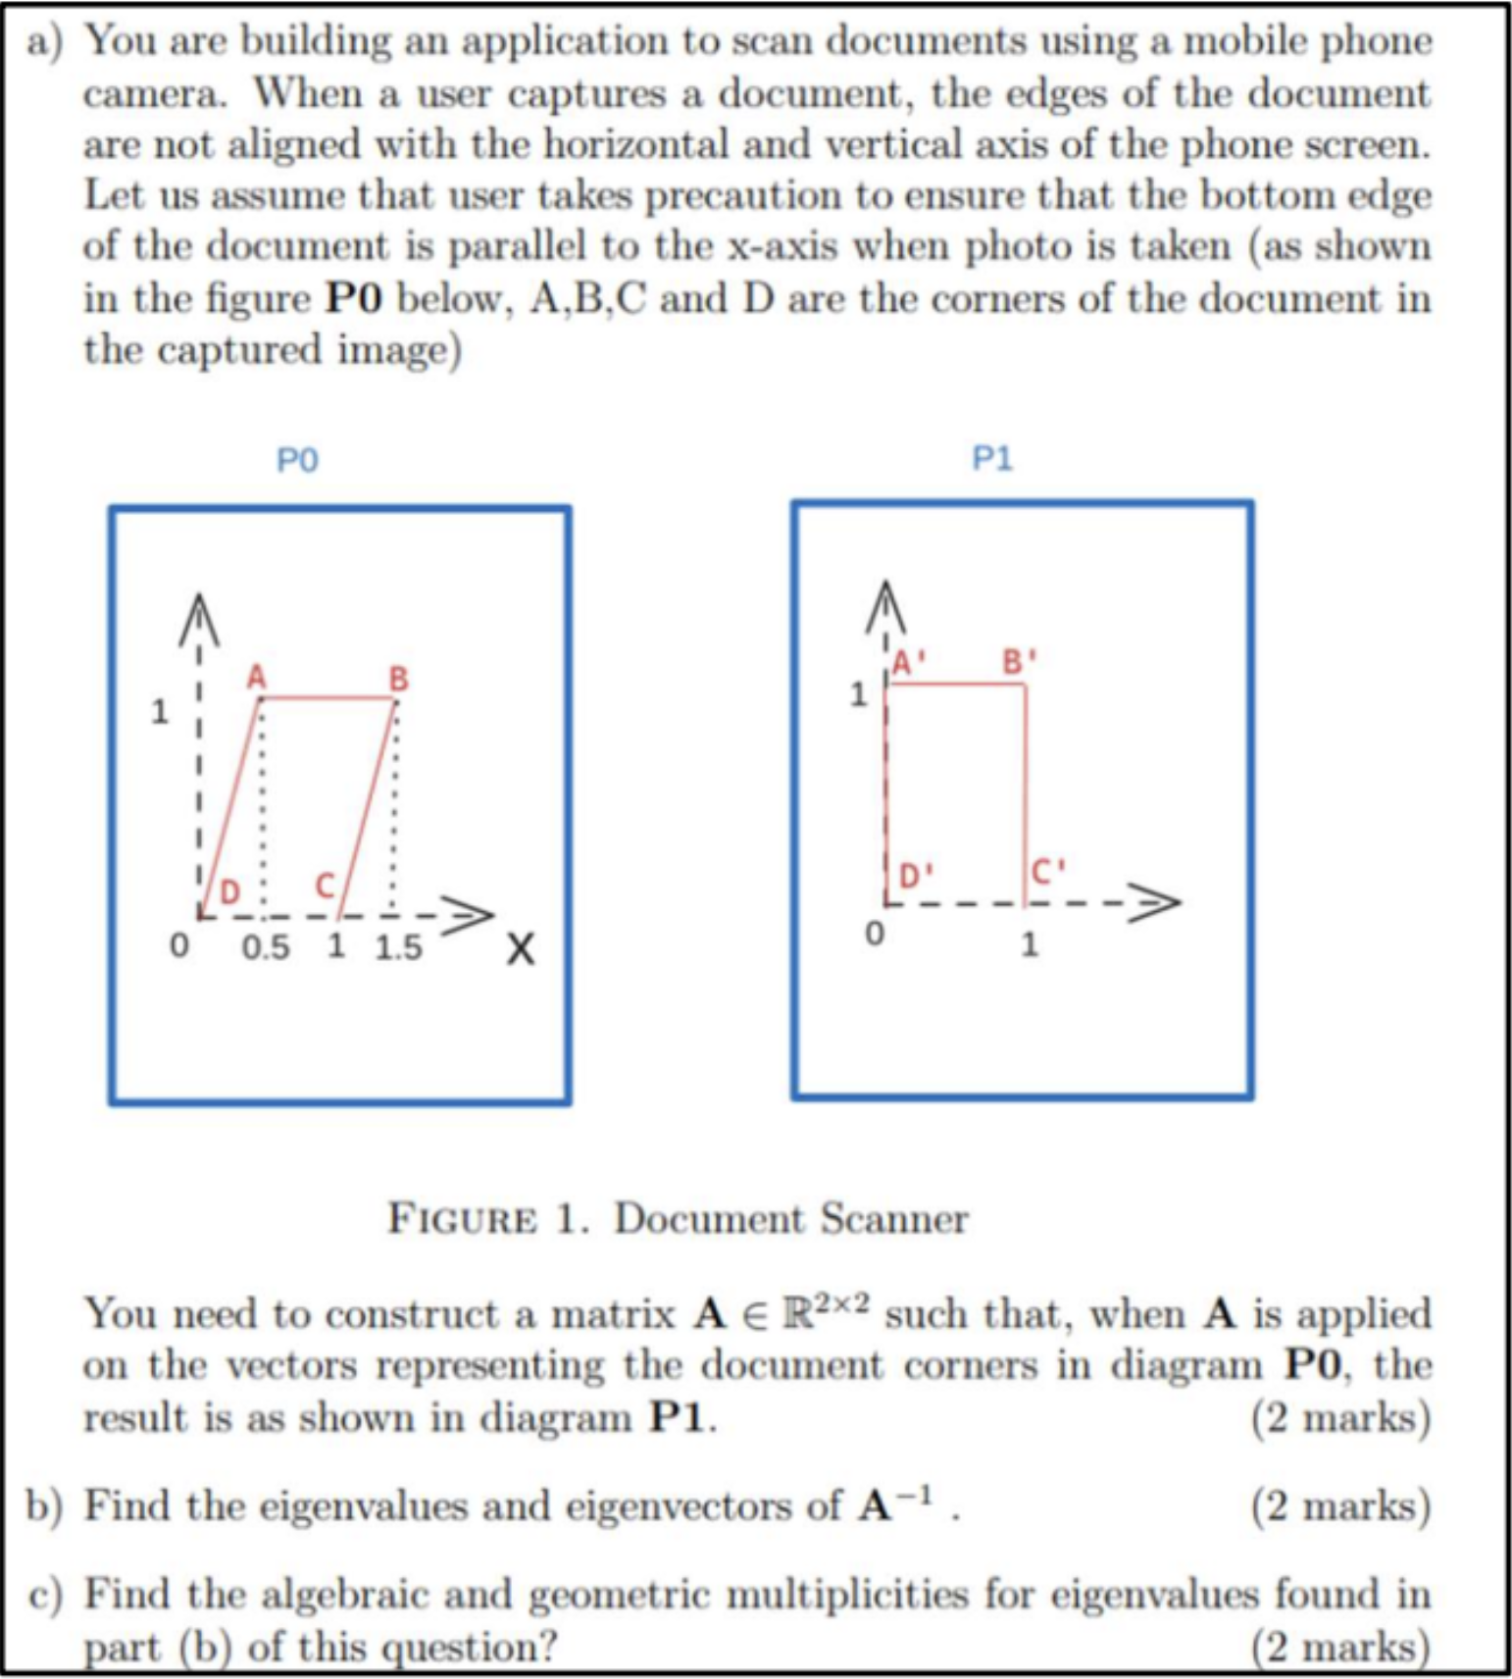

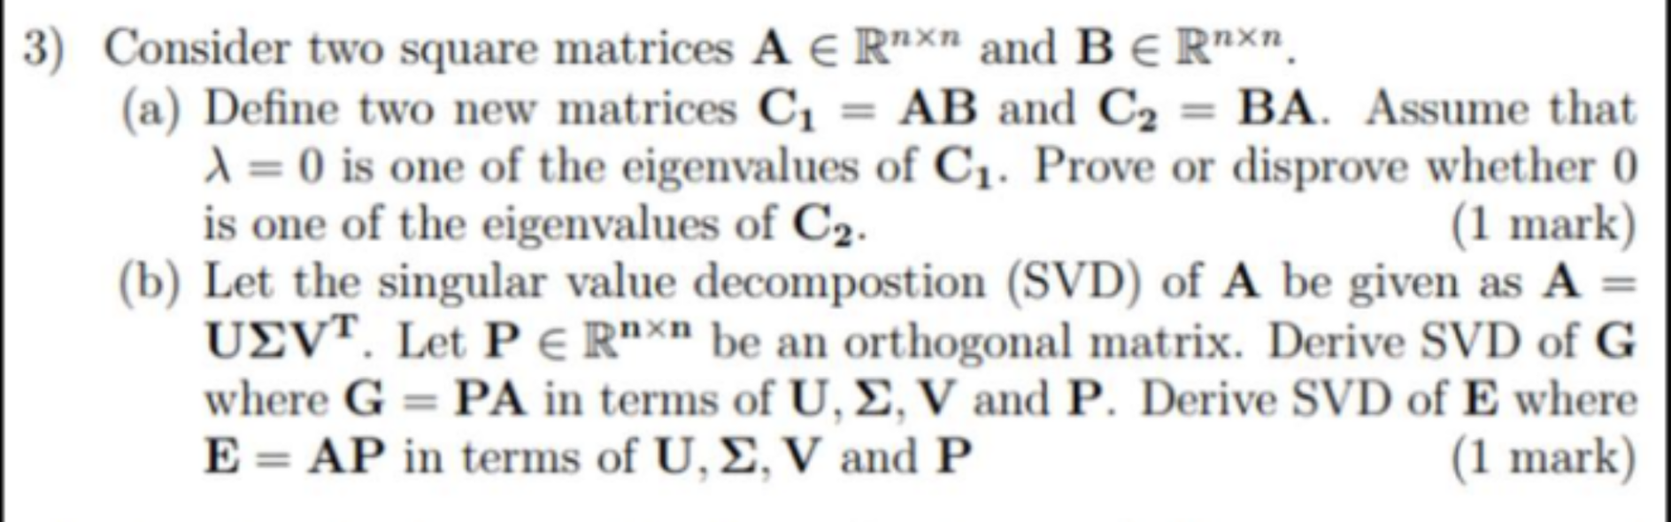

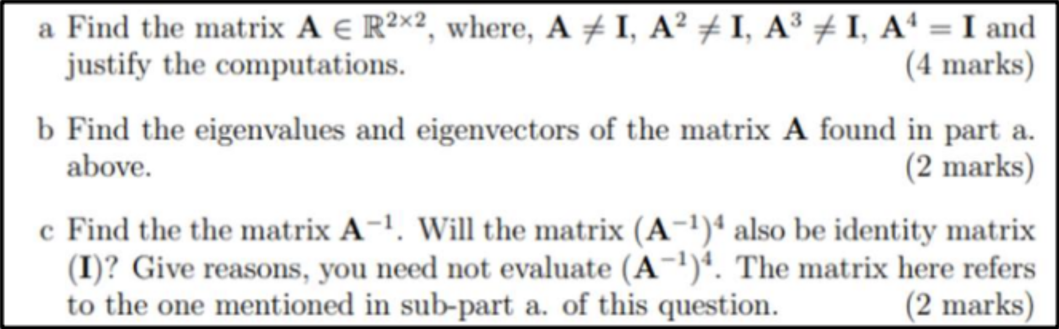

M4 — Vector Calculus

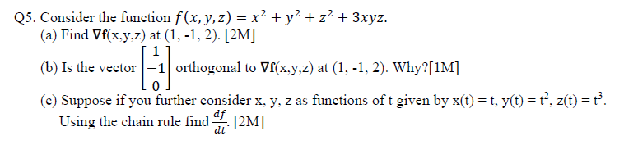

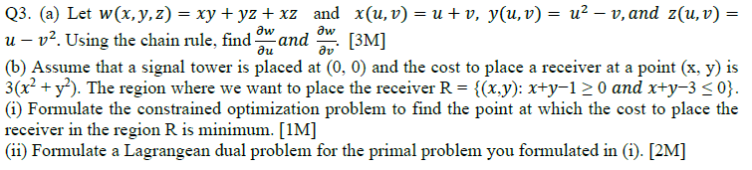



**2020 MidSem Regular**

**Q1**

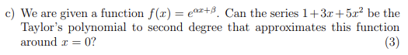

**Q3**

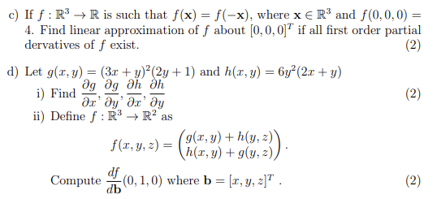

**2022 MidSem**

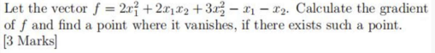

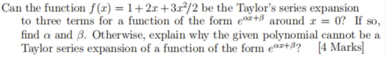

**2022 EndSem Regular**

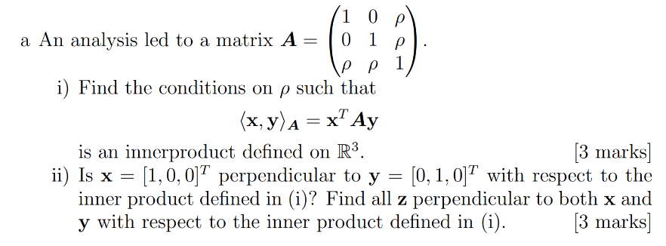

**Q2**

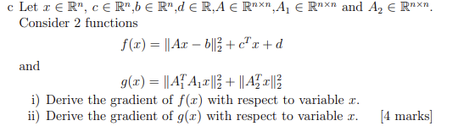

**Q3**

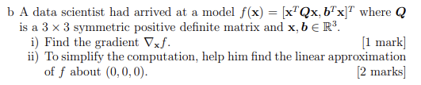

**2022 EndSem Makeup**

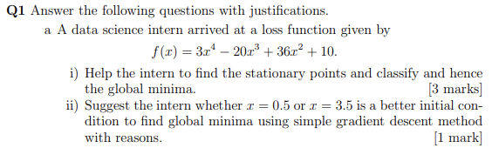

**Q1**

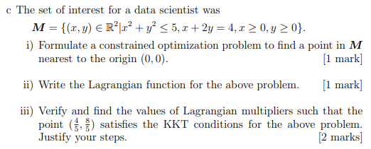

**Q3**

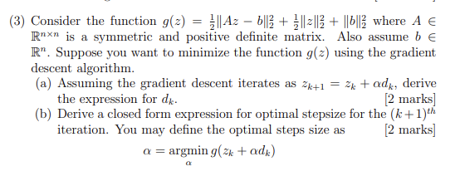

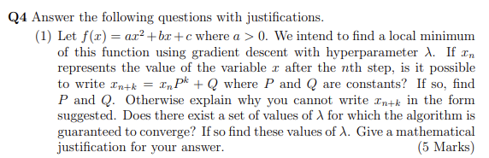

**2023 EndSem Makeup**

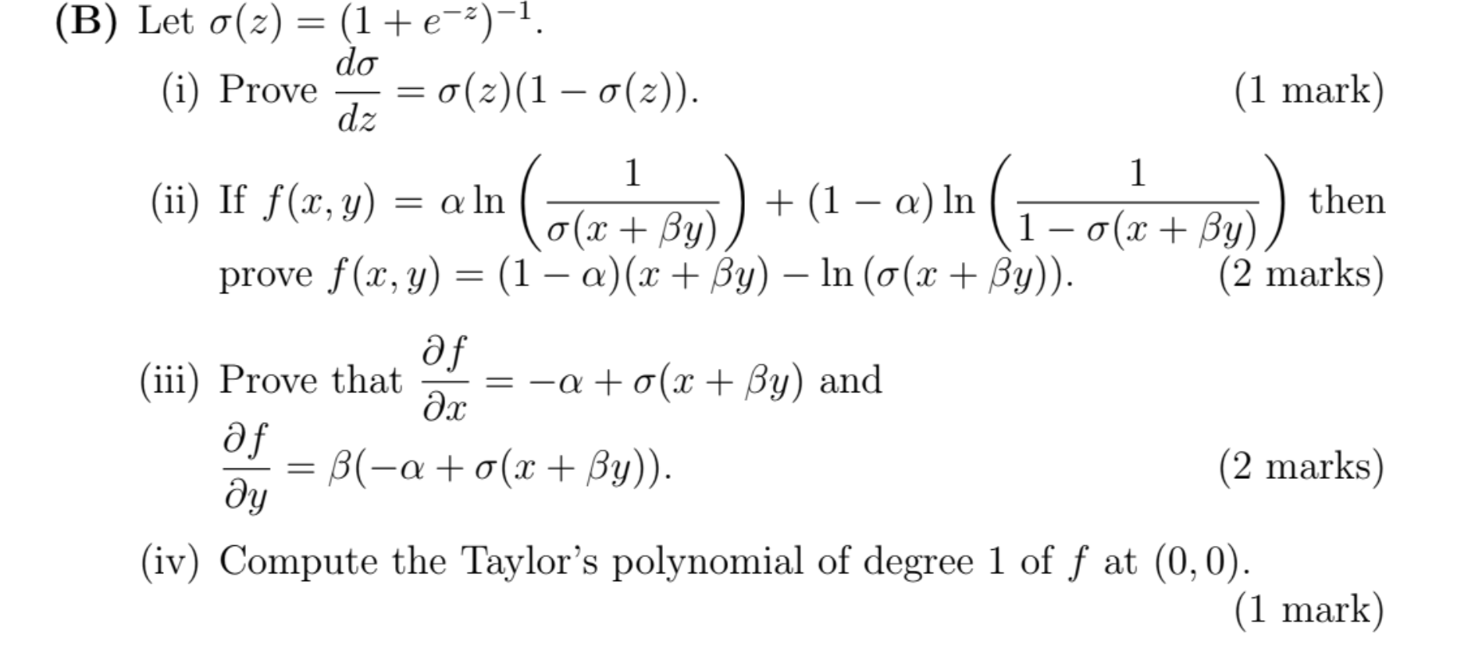

**2023 End Sem Regular**

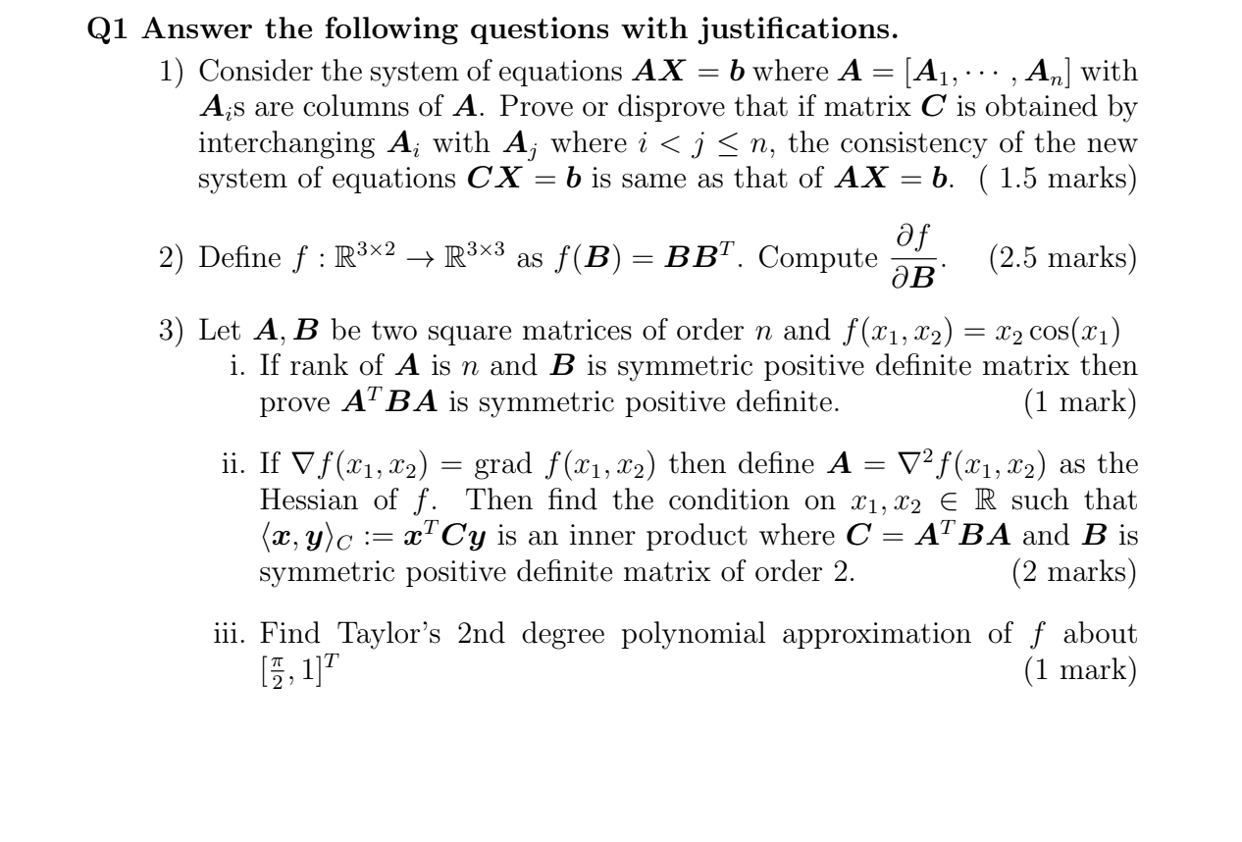

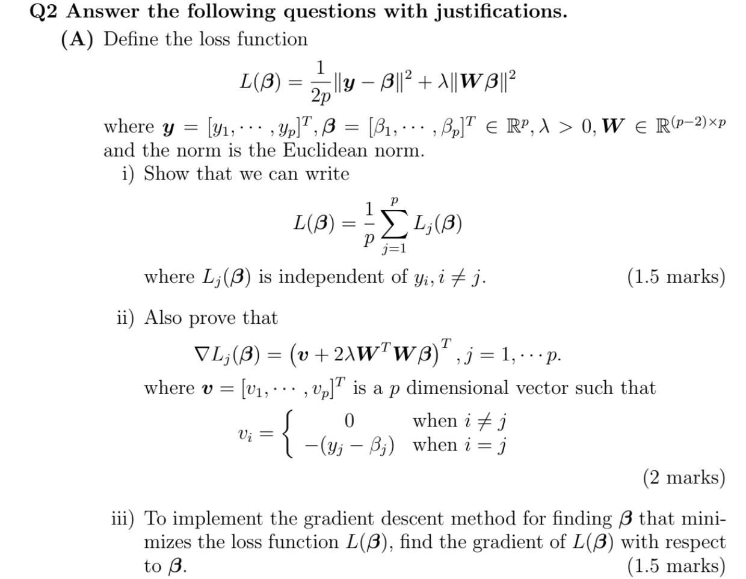

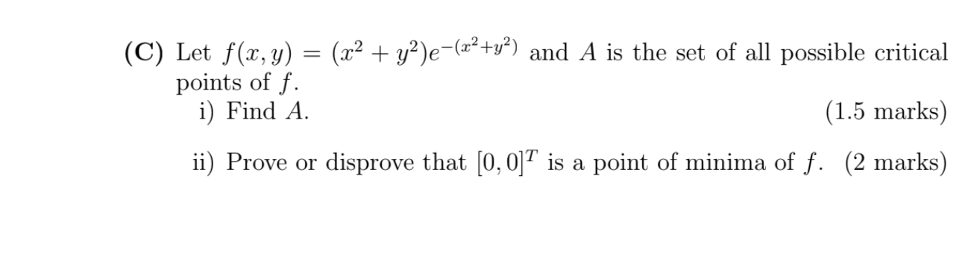

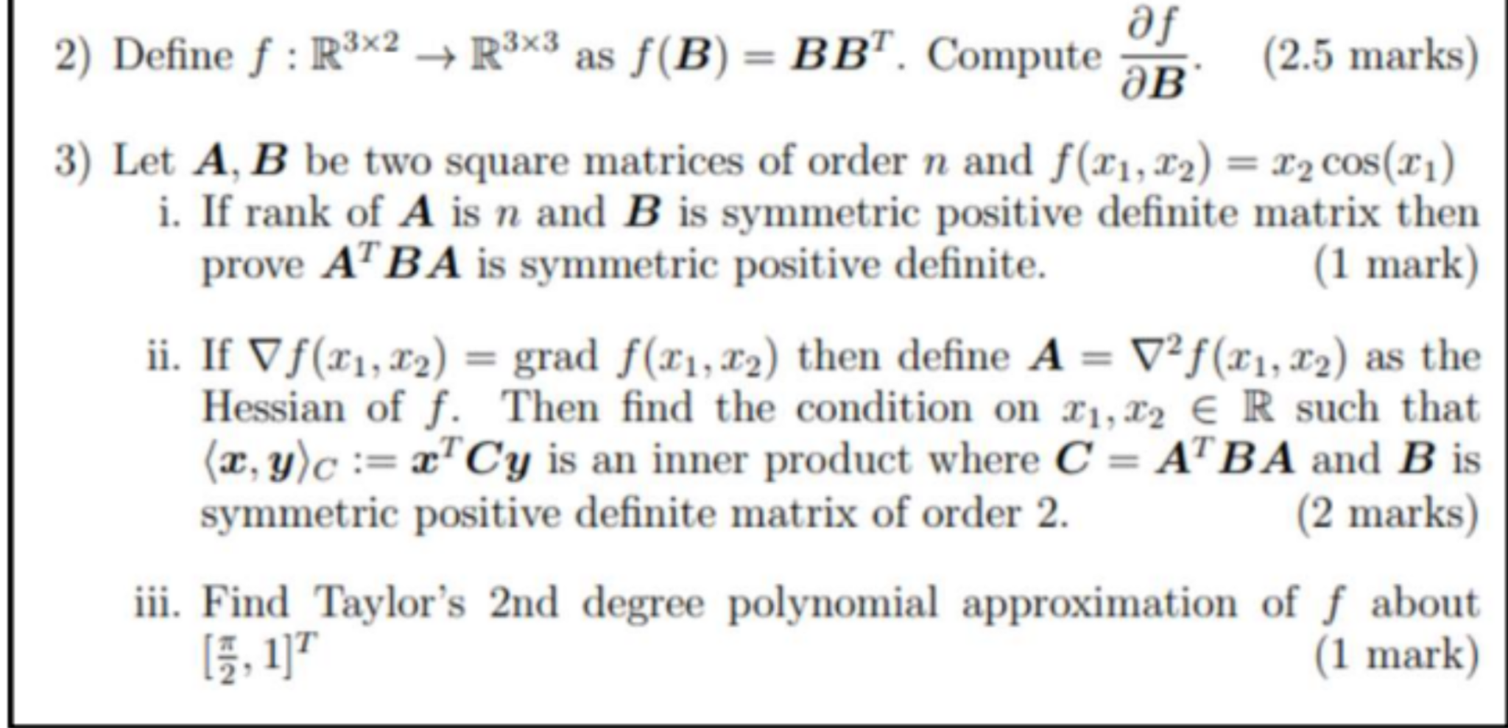

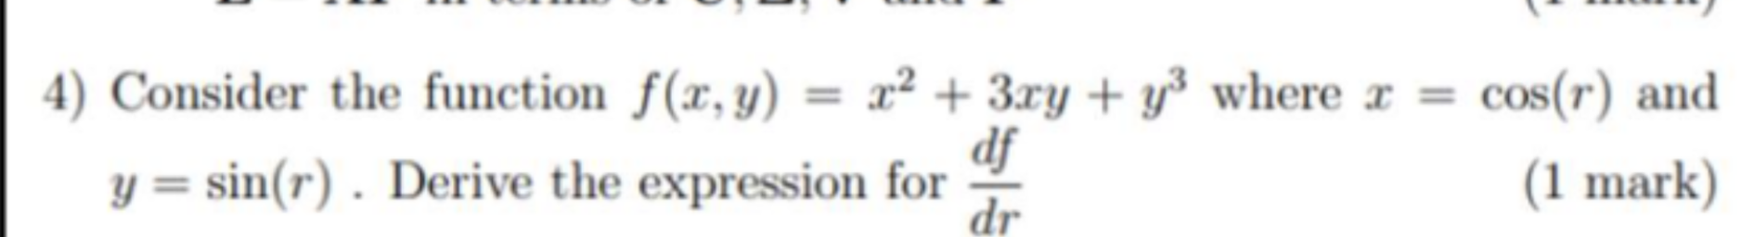

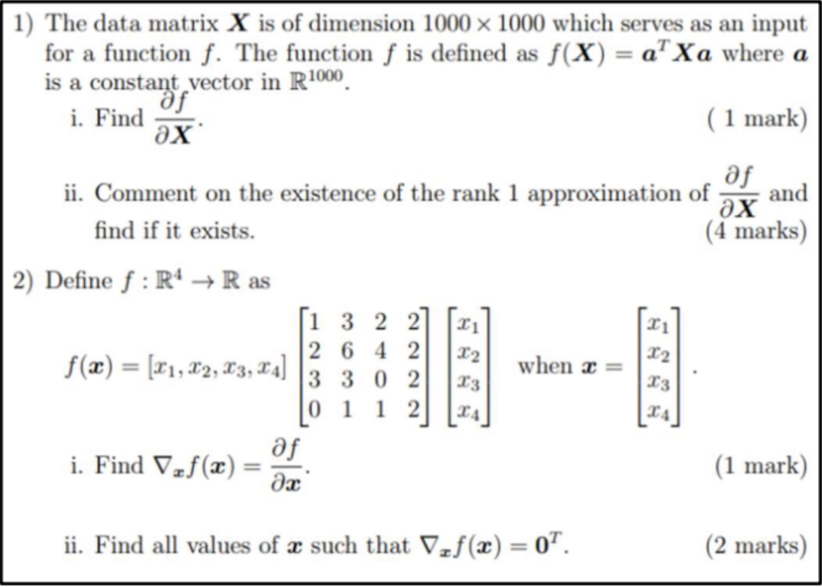

M5 — Continuous Optimization

**2023 EndSem Makeup**

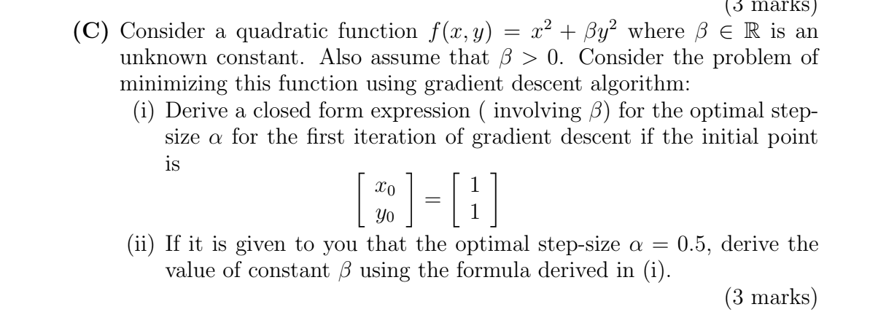

**2023 EndSem Regular**

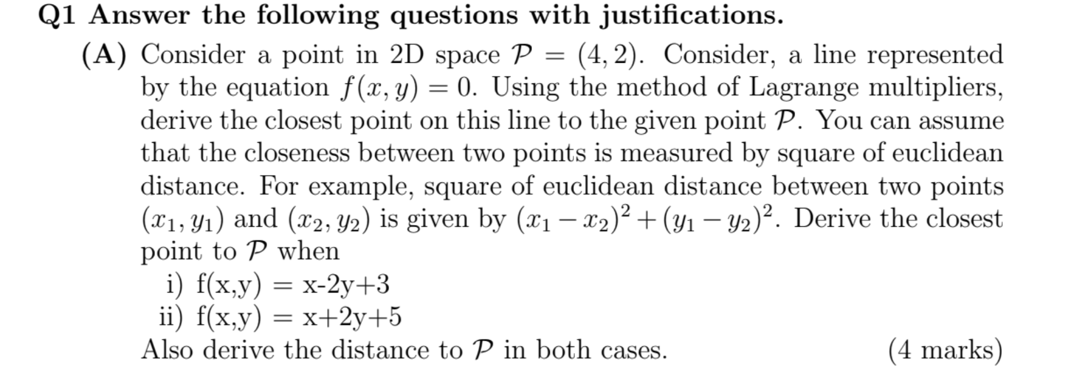

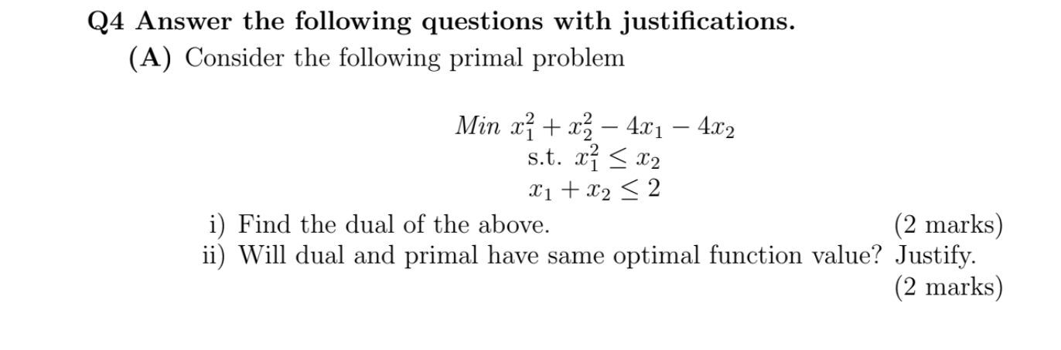

M6 — Nonlinear Optimization

**2023 EndSem Makeup**

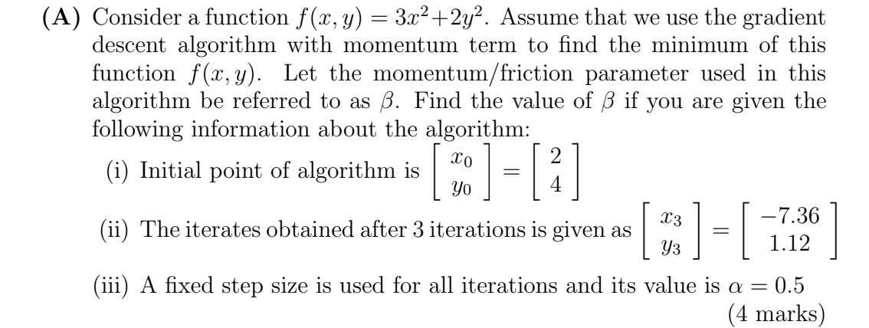

M7 — Dimensionality reduction and PCA / SVM

**2023 EndSem Makeup**

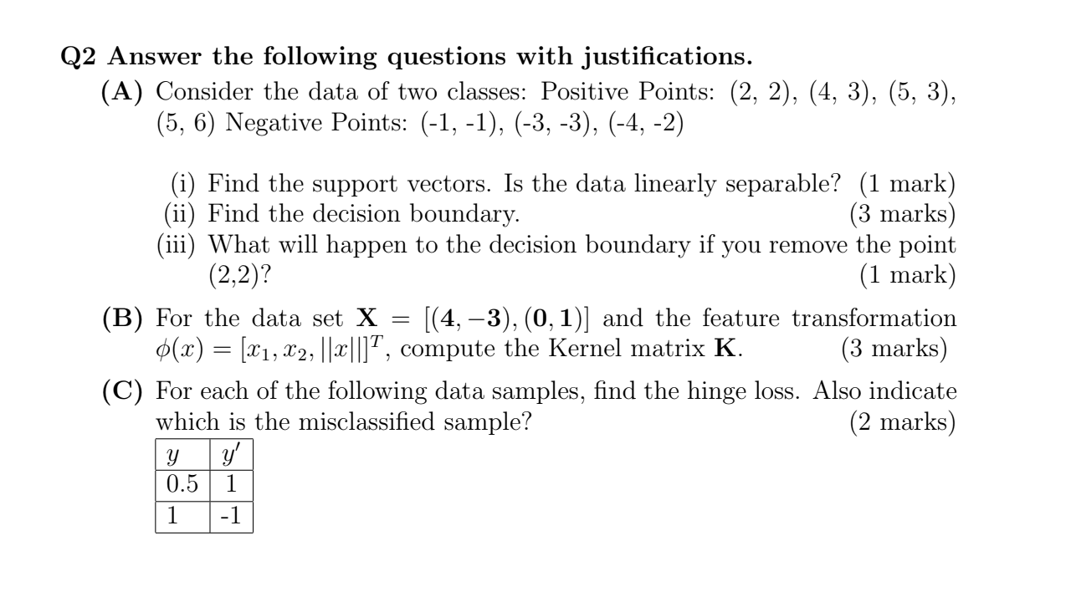

**2023 EndSem Regular**

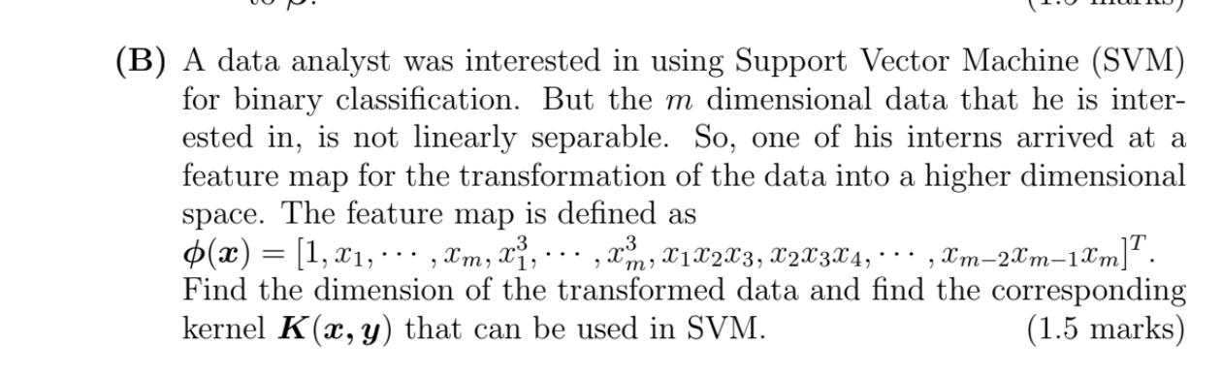

**2023 EndSem Makeup**

